Assignment 1 Visualization
Name: Faisal Zulfiqar
Student ID: 22010044
Subject: Applied Data Science

GitHub Assignment Data Link:
https://github.com/Faisal-Zulfiqar786/Applied-Data-Science-Assignment-1.git

Links of Data Sources:
CSV Data For Line chart(File= Line Plot)
https://stats.oecd.org/index.aspx?DataSetCode=AV_AN_WAGE

CSV Data for Bar Chart (File=GDP of Pak.csv)
https://www.macrotrends.net/countries/PAK/pakistan/gdp-gross-domestic-product

CSV Data For Pie Chart(File= Pie chart)
https://www.gov.uk/government/statistics/public-spending-statistics-release-july-2022/public-spending-statistics-july-2022

Line Plot:

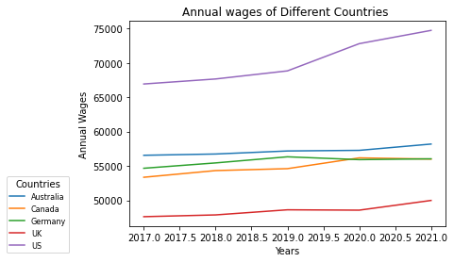

Description:
This Program imports two python libraries: pandas and matplotlib.pyplot. It reads data from a CSV file named “Line Plot.csv” using the read_csv() function of the pandas library and stores it in a variable named “output”. Then, it prints the data using the print() function.
Next, the program extracts data from the “output” variable and plots it using the plot() function of the pyplot module of the matplotlib library. It crates a line plot by years are on the X-Axis and the annual wages on the Y-Axis for five countries: Australia, Canada, Germany, the United Kingdom, and the United States. Also the plot includes legend with the names of the countries, which is positioned in the lower left corner.

Finally, the program add labels to X-Axis and Y-Axis using the xlabel() and ylabel() functions, respectively. It also adds a little to the plot using the title() function and displays the plot using the show() function.

Bar Plot:
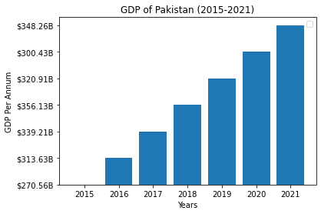

Description:
This program reads a CSV file named “GDP of Pak.csv” into a pandas DataFrame. The program then extracts two columns named “Year” and “GDP” from the DataFrame and assigns them to the variables “x” and “y”. It then creates a bar plot using the extracted data, where the “Year” values are plotted on X-Axis and the “GDP” values are plotted on the Y-Axis.

This Program then customizes the plot by adding a title, axis labels , and a legend . Finally, the plot is displayed using the ‘plt.show()’ function from the matplotlib library.

The resulting plot displays the GDP of Pakistan from the years 2015 to 2021 on a bar chart, with the GDP per annum on the y-axis and the years on the x-axis.

Pie Plot:
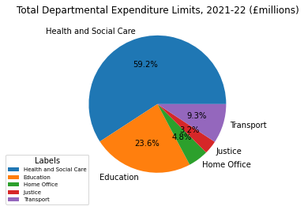
Description:
This program reads data from a CSV file named ‘pie chart.csv’ , which contains information about department budgets. It replaces commas in the ‘Budget’ column with periods and converts the resulting strings to float values.

Afterward, it extracts the ‘Departments’ column as labels and the ‘Budget’ column as values. Then, it plots a pie chart using the ‘values’ and ‘labels’ variables. The ‘autopct’ argument is used to display the percentage values on the chart.

Lastly, it adds a legend to the chart, which includes the labels from the ‘Departments’ columns, sets a title for the legend, adjusts the location and font size, and positions it at the bottom left corner. Finally, the program shows the plot using the ‘plt.show()’ command.

